ENSE 374

Milestone 3: Intranet Content Strategy Proposal

Software Group B

Members: Avery, Nic, Renz, Jiahao, Jinkai, Mackenzie

Table of Contents:

Purpose 3

Content Strategy Overview 3

Substance 3

Workflow 3

Governance 3

Structure 4

Programs 4

Faculty 5

Research 6

Forms 7

Info 8

Images:

Image 1 Program Content Structure Diagram 5

Image 2 Faculty Content Structure Diagram 6

Image 3 Research Content Structure Diagram 6

Image 4 Forms Content Structure Diagram 7

Image 5 Info Content Structure Diagram 8

**Purpose:**

The purpose of this milestone is to propose a content strategy for the Faculty of Engineering’s Intranet. The content model, page, navigation structure, workflow and security and privacy should be addressed.

**Content Strategy:**

Substance:

The substance of this content strategy model addresses both the content and its intended recipient. The content is intended for faculty and staff only as it is the Engineering’s intranet. This means content removed from the main site for a lack of suitability to students can be implemented. Research was a section flagged for removal and will be implemented as a main part of the intranet as this allows for potential cooperation between faculty members in projects and research where a professor’s expertise may be needed. As well as research, forms, committees, programs and general information will be main headings. Forms will be included as a main heading due to the importance of navigation and findability as stressed by Meigen and Robyn. Overall content is included to ensure items are easy to find and use in the intranet.

Workflow:

The delivery of content and interactions the user has to make are extremely important to create a site where items are accessible and easy to navigate to. To allow for content delivery to be specific, content will generally be separated by programs, such as program related forms, or program courses and committees. This separation allows content unrelated to the user to be filtered out, general forms may have a general place or be listed in each program as necessary. As well, the ability to search by keywords in metadata or to search by subsections is important in content. This allows for intuitive workflow and information to be findable. The importance of findable information was also noted by Meigen as this would allow explanation of locations of files to be easy to understand. For example, by searching forms by keywords this reduces navigation through clicks which can be hard to explain in some cases. Additionally, dropdown menus can help reduce the need for ‘clicks’ in navigation by skipping to subsections when a user knows what they are searching for. This allows for the system to remain quick after users learn how to use the system while permitting users to learn the system easily initially.

Governance:

Consideration of governance is quite important as the security and archival procedures are strict to ensure confidential information is kept safe. Changes should ideally be made to ensure the learning process is quick and goes well overall. Changes to the system after implementation should be easy, in the case of metadata, new items should be quick to add to allow the items to be processed and updated quickly. The archival of old forms should be a set standard and files removed from links as needed. Updated versions of forms should potentially contain identifying dates to convey the age of a form. Security is a key part of the governance of the page. Confidentiality of some documents require a set user group to only have access as indicated by Meigen. Glenn warned that separate user groups and security roles can be hard to manage long-term. Based on both of these items we decided to separate documents and pages first based on program, this allows a general security that could be easily repealed if deemed unnecessary. As well, inside the programs’ the individual committees might have confidential files and information, this would be a larger area of concern in terms of confidentiality as long as committees and boards are minimal creation of security roles should be manageable. Admin staff should have the ability to set the security roles of others and add files, and update forms as needed to ensure maintainability long-term.

Structure:

The structure of the intranet provides the basis for organization and display, coupled with the workflow helps to create an intuitive website as requested by staff. The site was organized into five main groups: Programs, Faculty, Research, Forms, and Info. These groups can be adjusted but currently allow for important information to be broken down into distinct groups for easy navigation.

Programs:

The structure and work flow of Programs in shown below in Image 1. The programs are broken into ESE, ISE etc to allow for users of a certain program to quickly eliminate unnecessary information from the beginning. Each program, such as SSE, will contain general program info and further links to courses, faculty, forms and committees. The faculty and forms links will link to subsections of the corresponding title to reduce the duplication of information while allowing easy navigation. This also allows for intuitive navigation based on users understanding, if a user wants a program related form either option will yield the same result and is easy to follow as a process. Courses and committees will have the ability to be sorted if there is a large number.

Image 1: Program Content Structure Diagram

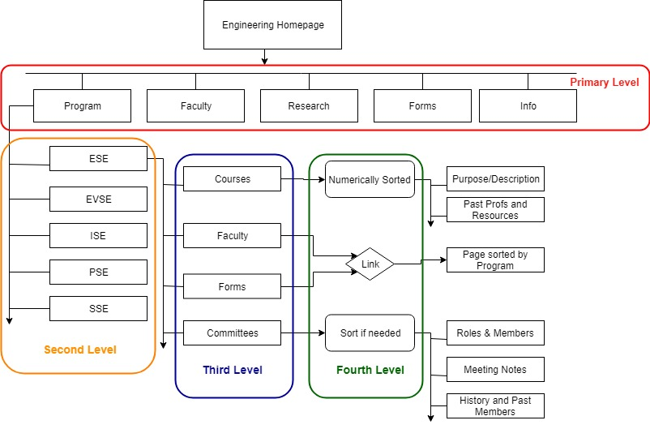

Faculty:

The faculty page is organized quite similarly to the implementation found in the public site. This allows for continuity between the two sites, as well with the addition of searching in the navigation this allows for easier navigation and a simpler navigation. The faculty diagram in image 2 below, shows the initial side bar options which break down the faculty into sub categories listed alphabetically for easy searching. This method also allows for the easy addition of new staff and removal of staff when needed. This can be done by simply updating a faculty listing and potentially using security groups to display the other options such as Admin Staff or Program Chairs to reduce the need of making sure each addition of staff or change of position is updated in the faculty listing.

Image 2: Faculty Content Structure Diagram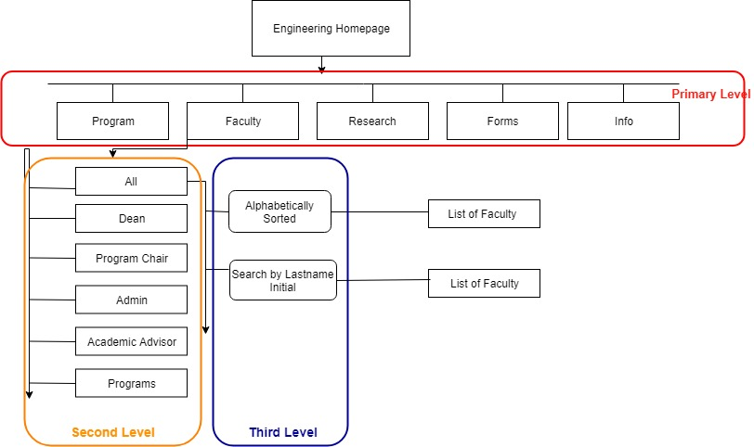

Research:

Research organization is like the faculty organization, however only additional organization by program will be possibly. This keeps the navigation of the structure simple to understand. Along with the program organization, you will be able to search through the various faculty by research interests on a keyword basis. This allows for more discovery in research interests and allows for the open organization in the page. As pictured below in image 3. The research page with contain faculty members and their research interests in a list form.

Image 3: Research Content Structure Diagram

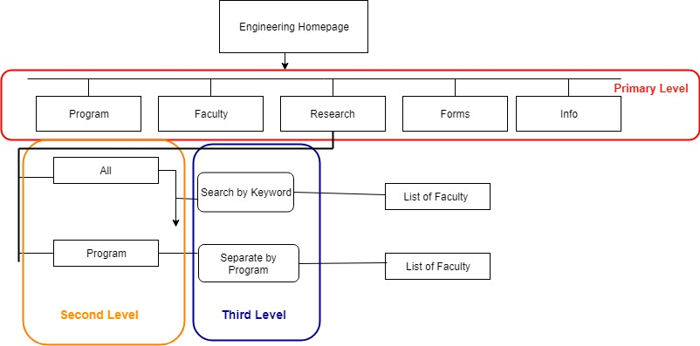

Forms:

Forms were a main point of consideration from Meigen and Robyn. As such, an emphasis on usability and understanding was used. To implement this an initial list style was used, this is similar to both the faculty and research organizations. However, the forms are broken down into various categories and are searchable by keywords. The categories can be changed for improved structure and a more intuitive organization for use by users. The search function allows users who know what they are looking for, either in general or specifically to easily call up a smaller list of forms. Inspiration for the form categories and search function was taken from shopping sites where meta data allows results to be filtered by keyword or a selected category. This inspiration comes from a need to provide users with their information in a quick and familiar way. Image 4 contains an example of the categories and what would be found in each category in the current organization.

Image 4: Forms Content Structure Diagram

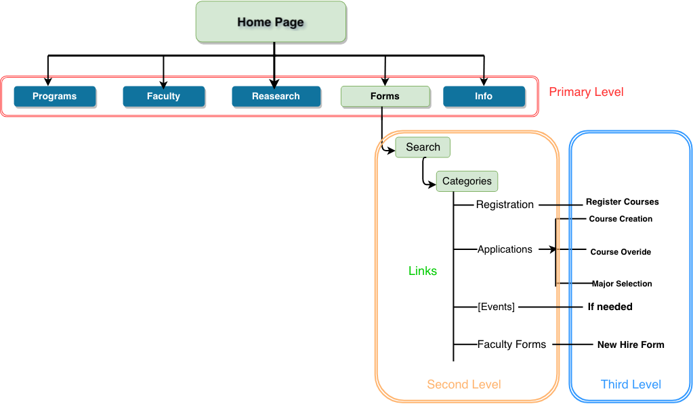

Info:

The information category is a general information category to include information that might be missed in other categories or overlooked. This includes Admission/Graduation which would be used for information academic advisors and admin staff could find for students easily when needed. The Events category was a category initially on the main bar, it was removed because of its potential lack of use and ability to be overlooked. This would contain upcoming faculty, and program events in a calendar style. The New Hire category is used to give New Hires general information and access to necessary forms easily with little navigation. Contact allows for questions or concerns to be easily posed to IT and Admin staff as needed. The organization of information could be reworked to eliminate it but at the possible detriment of the organization present in other categories.

Image 5: Info Content Structure Diagram

